 

Department of Computer Science & Information Technology

III Year, V Semester (Batch 2022-2026)

Lab Record Submission of

Linux (Lab)

Subject Code – CSIT-505

Submitted to: Submitted by:

Prof. Nidhi Nigam Varun Purohit

 

**Name: Varun Purohit Enrollment No: 0827CI221148**

**Course Name: LINUX Subject Code: CSIT-505**

**Subject Name: LINUX LAB**

**INDEX PAGE**

|  |  |  |  |  |
| --- | --- | --- | --- | --- |
| **Experiment Name** | **Experiment Date** | **Submission Date** | **Page No.** | **Sign** |
| Introduction of linux operating System |  |  |  |  |
| Study of basic user and sell command |  |  |  |  |
| Study linux architecture Difference between shell and kernel |  |  |  |  |
| Understanding the Linux File System |  |  |  |  |
| Study of Linux editors with their command specification |  |  |  |  |
| Create a file called wlcc.txt with some lines  and display how many lines, words and characters are present in the file |  |  |  |  |
| Append 10 more simple lines to the file and display |  |  |  |  |
| Study and use of cmd for changing file permission. |  |  |  |  |
|  |  |  |  |  |
|  |  |  |  |  |
|  |  |  |  |  |
|  |  |  |  |  |
|  |  |  |  |  |
|  |  |  |  |  |
|  |  |  |  |  |
|  |  |  |  |  |
|  |  |  |  |  |

**Introduction to Operating Systems**

An Operating System (OS) is a crucial software that acts as an intermediary between computer hardware and the user. It manages hardware resources and provides essential services for the execution of various applications. Here’s a brief overview:

**Types of Operating Systems-**

• Batch Operating Systems: Execute jobs in batches without user interaction.

• Time-Sharing Operating Systems: Allow multiple users to interact with the system simultaneously.

• Distributed Operating Systems: Manage a group of independent computers and make them appear as a single system.

• Real-Time Operating Systems (RTOS): Designed for systems that require real-time processing.

• Embedded Operating Systems: Specialized OS designed for embedded systems with limited resources.

**Examples of Operating Systems:**

• Windows

• Linux

• macOS

• Android

• iOS

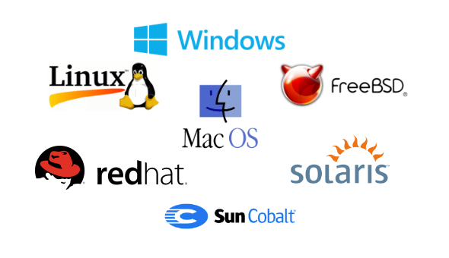

**Services of Operating Systems**-

* Process Management: Manages the execution of processes, including scheduling, creation, and termination.
* Memory Management: Allocates and deallocates memory space for processes, ensuring efficient memory usage.
* File System Management: Handles the creation, deletion, reading, and writing of files and directories.
* Device Management: Manages hardware devices, facilitating communication between the OS and peripheral devices.
* Security and Access Control: Protects system resources through user authentication and access permissions.
* User Interface: Provides an interface (CLI or GUI) for users to interact with the system.
* Error Detection and Handling: Detects errors in hardware and software, ensuring system stability.

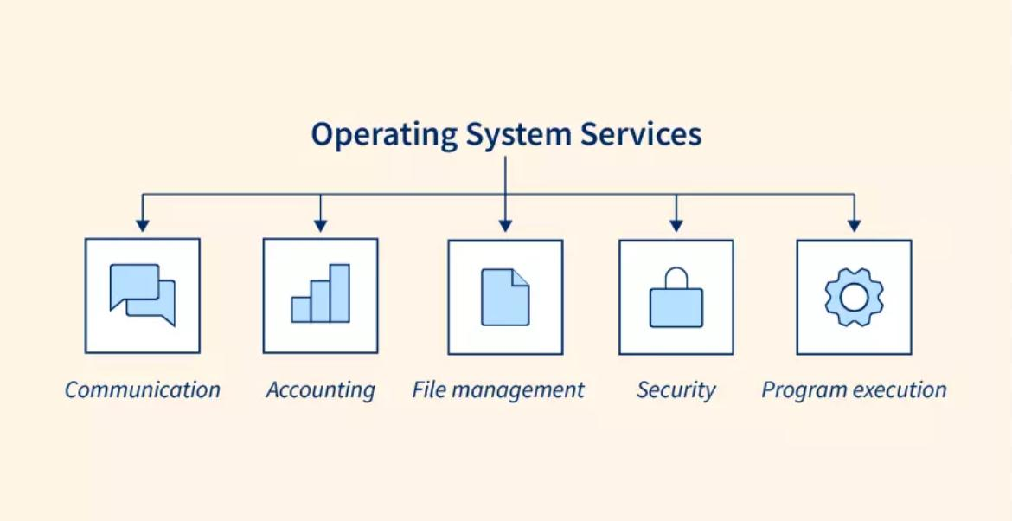

**Need for Operating Systems**

Operating Systems are essential because they manage hardware resources, provide a user interface, enable application execution, and ensure system security and stability, making it possible for users and software to interact with the computer efficiently.

**LINUX OS:**

Developed by Linus Torvalds in 1991, the Linux operating system is a powerful and flexible open-source software platform. It acts as the basis for a variety of devices, such embedded systems, cell phones, servers, and personal computers.

Linux, that's well-known for its reliability, safety, and flexibility, allows users to customize and improve their environment to suit specific needs. With an extensive and active community supporting it, Linux is an appealing choice for people as well as companies due to its wealth of resources and constant developments.

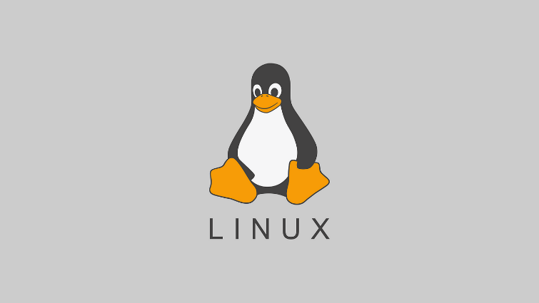

**History of linux:**

A popular open-source operating system is Linux. It was initially created by Linus Torvalds in 1991. At the time, Torvalds was a computer science student at the University of Helsinki, Finland and began working on the Linux project as a personal endeavour.

Early versions of Linux were primarily used by technology enthusiasts and software developers, but over time it has grown in popularity and is used in various types of devices such as servers, smartphones, and embedded systems. Linux is considered one of the most stable, secure and reliable

operating systems and is widely used in servers, supercomputers and enterprise environments.

Today, Linux is one of the most widely used operating systems in the world, with an estimated 2.76% of all desktop computers and more than 90% of the world's top supercomputers running on Linux, and approx. 71.85% of all mobile devices run on Android, which is, you guessed it, Linux-based. The Linux community has expanded to include thousands of developers and users who work on the creation and upkeep of the operating system.

Nowadays Linux has many distributions (versions) namely:

* Ubuntu
* Fedora
* Arch
* Plasma
* KDE
* Mint
* Manjaro

**Linux Distributions**

Linux distributions (distros) are different versions of the Linux operating system, each tailored for specific needs. They combine the Linux kernel with a package management system, software, and utilities. Here are a few popular distributions:

1. Ubuntu: User-friendly, popular for desktops and beginners, with strong community support.

2. Fedora: Cutting-edge features, backed by Red Hat, often used by developers.

3. Debian: Known for stability and extensive software repositories, often used on servers.

4. CentOS: A free, community-supported version of Red Hat Enterprise Linux, popular in enterprise environments.

5. Arch Linux: Lightweight and highly customizable, aimed at advanced users.

6. Mint: Based on Ubuntu, it's designed to be easy for newcomers, with a familiar interface.

**Applications of linux**

1. Mozilla Firefox



Firefox is the default browser for various Linux distributions such as Linux Mint and Ubuntu. It is the fastest web browsing software for Linux with an incredibly user-friendly interface. As a Linux application, Its auto-update feature makes it a very convenient application.

2. Thunderbird



Thunderbird is a free and powerful yet easy-to-use email client which helps to manage your emails with ease. The wizard acts as an assistant that gives a walkthrough of this application of Linux. An unlimited number of accounts can be added and managed by this amazing software. This Linux application provides a better way to sort the mail folders.

3. LibreOffice

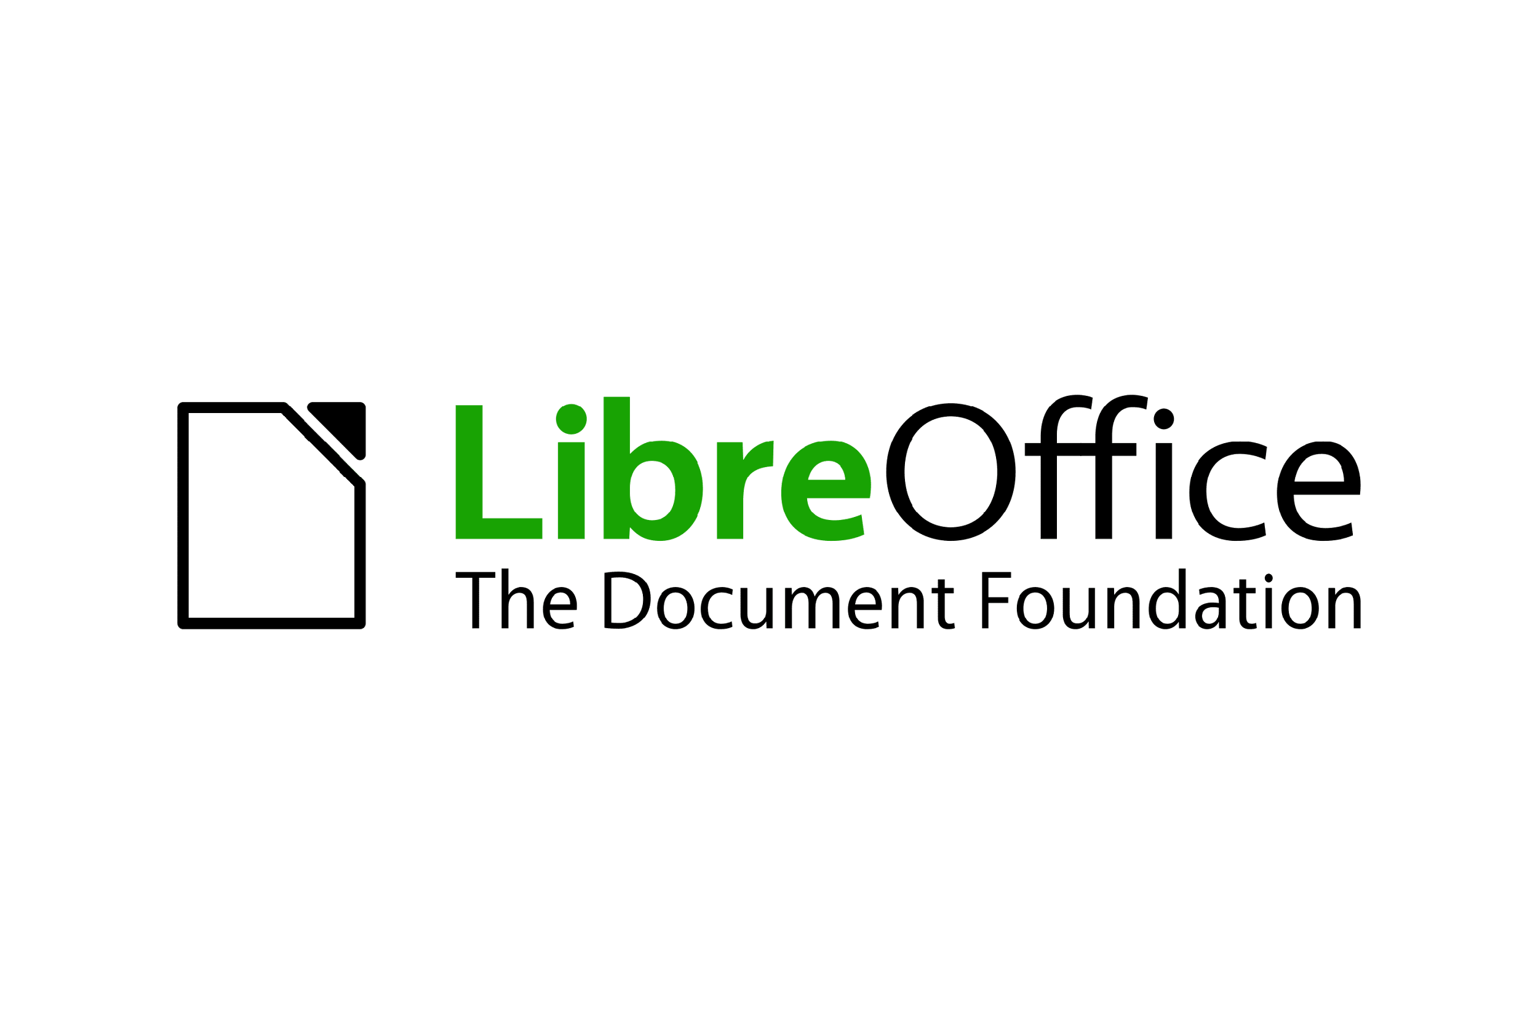

LibreOffice is free, complete, and one of the best office suites. It has a basic interface along with extraordinarily advanced features. These applications of Linux are pre-installed in Ubuntu and its derivatives. The documents can be saved in various formats such as DOC, DOCX, PPT, PPTX, XLSX, etc.

4. VLC Media Player



VLC is the most famous media player which supports any kind of audio or video files without the need to download additional codecs. It can also be used for clipping videos and helps in converting files from one format to the other such as flv to mp4.

5. Shortcut

Shortcut is an open-source and free video editing software available for Linux, macos as well as windows. It supports all kinds of audio and video formats including the latest 4K view

6. GIMP

GIMP is a free image editor that allows you to edit and retouch images by resizing, adding layers, noise reduction, cropping, and color adjustments. Photoshop plugins can also be added to GIMP.



7. Audacity

Audacity is an open-source digital audio editor and recording application that supports Windows, macOS, and Linux. It supports recording from multiple inputs such as a keyboard and a USB microphone simultaneously.



8. Visual Studio Code



Visual Studio Code is a free text editor provided by Microsoft for coding and programming. It is compatible with Linux, Windows, and macOS. This Linux application supports various plugins such as code refactoring, debugging, keyboard shortcuts, and default integration with Git.

9. VirtualBox

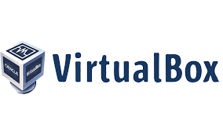

VirtualBox is a free and open-solsce virtualization machine owned by Oracle. It is a cross-platform software, allowing multiple operating systems to be run on a single computer. This Linux application is used for the simulation of various machines on a single device.

10. ClamAV

ClamAV is free and cross-platform anti-virus software for detecting various malicious viruses and removing them from servers and computers. This software is generally used on the server side as an email virus scanner.



**Linux Commands**

**1.man command:** man, command in Linux is used to display the user manual of any command that we can run on the terminal.

Syntax: man [option] [command]

Example:

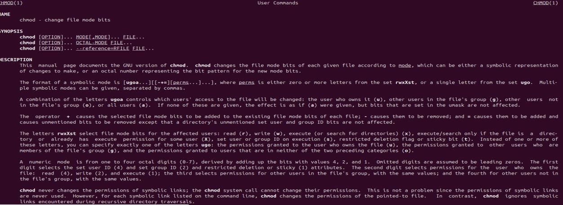

**2. whatis command:** whatis, command in Linux is used to get a one-line manual page description. In Linux, each manual page has some sort of description within it.

Syntax: whatis [option] [command_name]

Example:

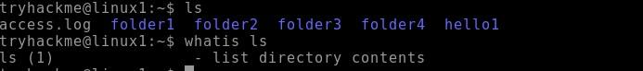

**3. Is command:** Is is a Linux shell command that lists directory contents of files and directories. It provides valuable information about files, directories, and their attributes.

Syntax: Is [option] [file/directory]

Example:

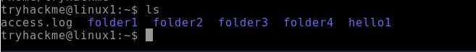

**4. cd command:** Linux cd command is used to change the current working directory (i.e., in which the current user is working). The "cd" stands for 'change directory.

Syntax: cd <dirname>

Example:

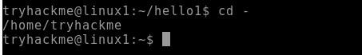

**5. mkdir command:** The mkdir stands for 'make directory'. With the help of mkdir command, you can create a new directory wherever you want in your system.

Syntax: mkdir <dirname>

Example:



**6. rmdir command:** This command is used to delete a directory. But will not be able to delete a directory including a sub-directory. It means, a directory has to be empty to be deleted.

Syntax: rmdir <dirname>

Example:

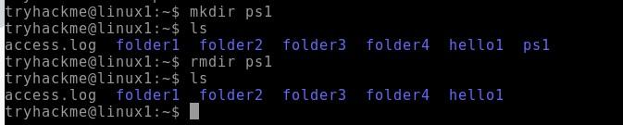

**7. date command:** date command is used to display the system date and time. date command is also used to set date and time of the system.

Syntax: date [OPTION]... [+FORMAT]

Example:



**8. wd command:** PWD stands for Print Working Directory. It writes the complete path name of the working directory to standard output.

Syntax: pwd [-options]

Example:

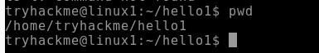

**9. whoami command:** Find out what user we're currently logged in as!

Syntax: whoami [OPTION]

Example:

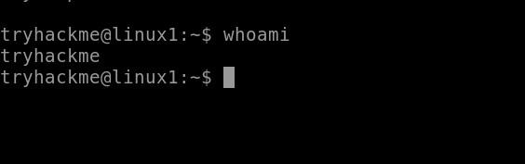

**10. su command:** The su command in Linux lets you switch to another user's account or execute commands as a different user.

Syntax: su [options] [username]

Example:

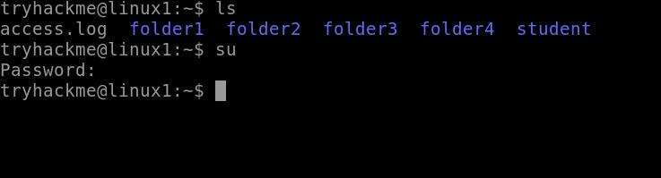

**11. sudo command:** The sudo command temporarily elevates privileges, allowing users to complete sensitive tasks without logging in as the root user.

Syntax: sudo [command]

Example:

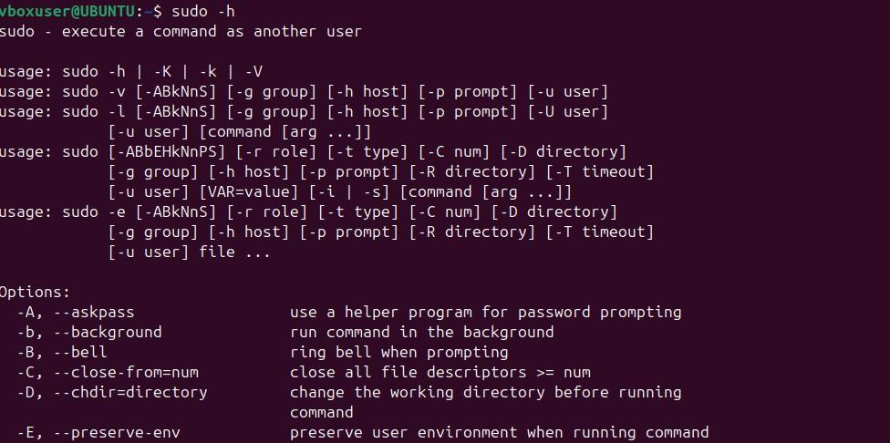

**12.ls-l command:** lists files and directories in long format, providing detailed information about each item.

Syntax:ls -I [OPTION] [FILE...]

Example:

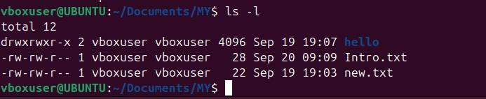

**13.ls-a command:** lists all files and directories, including hidden ones. Hidden files and directories in Linux start with a dot (.).

Syntax:ls -a [OPTION] [FILE...]

Example:

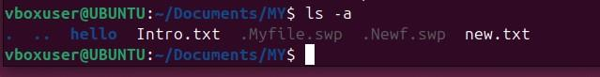

**14.cat command:** is used to concatenate and display the content of files. It stands for "concatenate" and is a simple but versatile command.

Syntax: cat [OPTION] [FILE...]

Example:



**15.cat>command:** is used to create a new file and input text into it directly from the command line. The > symbol redirects the output from the cat command into a new file, effectively creating the file and allowing you to enter its content interactively.

Syntax: cat > filename

Example:

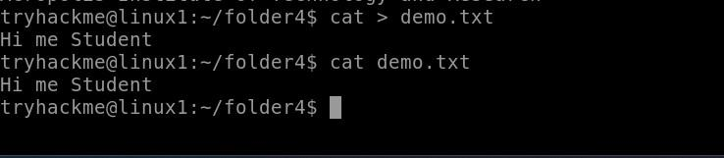

**16.kill command:** The kill command in Linux (located in /bin/kill), is a built-in command which is used to terminate processes manually

# Syntax: kill [signal] PID

Example:

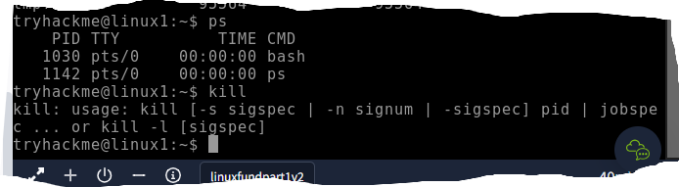

**17.cp command:** The cp command in Linux is used to copy files and directories

Syntax:cp [options] source destination

Example:

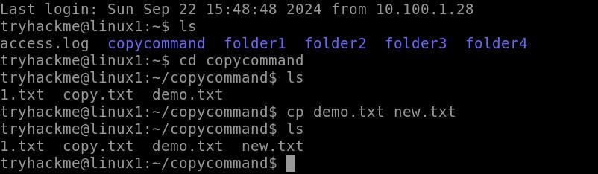

**18.mv command:** The mv command in Linux is used to move or rename files and directories

Syntax: mv [options] source destination

Example:

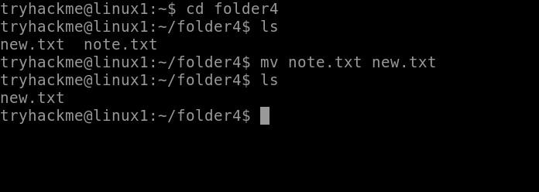

**19.grep command:** The grep command in Linux is a powerful utility used to search for specific patterns within files or input data.

Syntax: grep [options] pattern [file...]

Example:

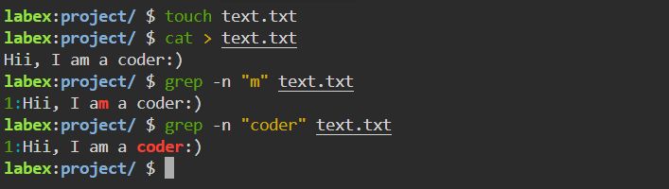

**20.touch command:** The touch command in Linux is used to create empty files or update the timestamps of existing files.

Syntax: touch [options] file...

Example:

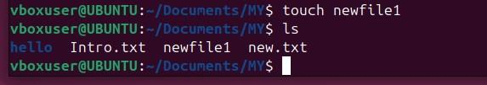

**21.Echo Command:** [echo command](https://www.geeksforgeeks.org/echo-command-in-linux-with-examples/) in Linux is specially used to print something in the terminal .

Syntax: echo <Text>

Example:



**22.df command:** The df (disk free) command in Linux is used to display information about the available disk space on your file systems.

Syntax: df [options] [file...]

Example:

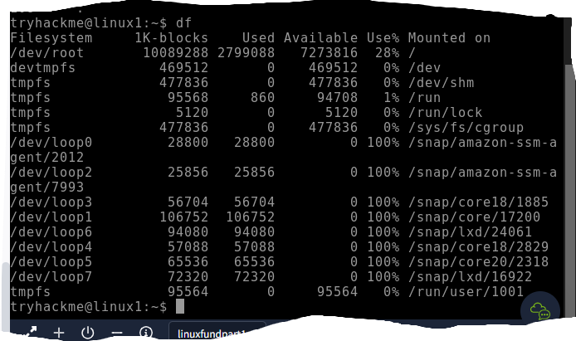

**23.passwd command:** is used to change a user's password. It can be used by users to change their own passwords or by administrators to change passwords for other users.

Syntax: passwd [options] [username]

Example:

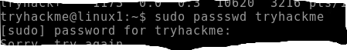

**24.head command:** The head command in Linux is used to display the beginning of a file or stream of data.

Syntax: head [options] [file...]

Example:

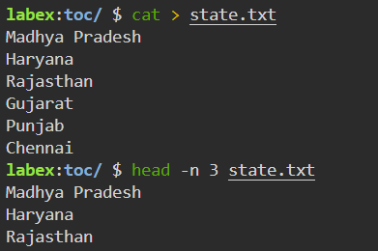

**25.tail command:** The tail command in Linux is used to display the end of a file or data stream.

Syntax: tail (options) [file...]

Example:

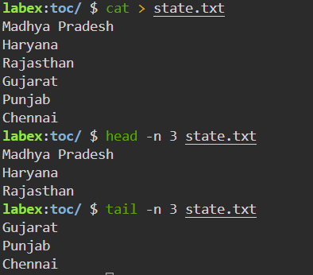

**26.find command:** The find command in Linux is a powerful utility used for searching files and directories within a directory hierarchy based on various criteria

Syntax: find [path] [expressio]

Example:

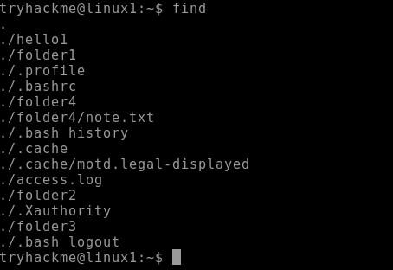

**27.ps command:** The ps command in Linux is used to display information about running processes.

Syntax: ps [options]

Example:

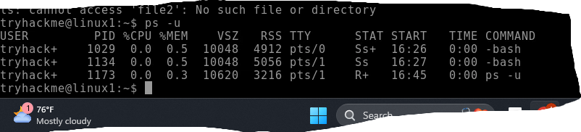

**28.pwd command:** The pwd command in Linux stands for "print working directory." It is used to display the current working directory of the user.

Syntax: pwd [options]

Example:



**29. cal command:** The [cal command](https://www.geeksforgeeks.org/cal-command-in-linux-with-examples/) is not the most famous command in the terminal but it functions to view the calendar for a particular month in the terminal. Let’s see how this works.

Syntax: cal<month><year>

Example:

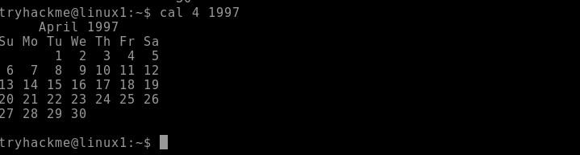

**30. uid command:** The id command displays the user ID (UID)

Syntax: id-u $(whoami)

Example:

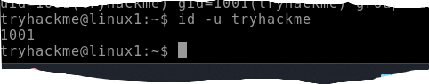

**31. gid command:** The id command displays the user ID (UID) and group ID (GID) information for the current user or a specified user.

Syntax: id username

Example:

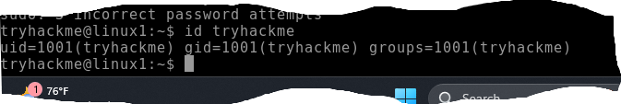

**32. wc command:** wc command in Linux stands for "word count" and is used to count lines, words, and characters in files. It can be a handy tool for getting quick statistics about file content.

Syntax: wc [options] [file...]

Example:

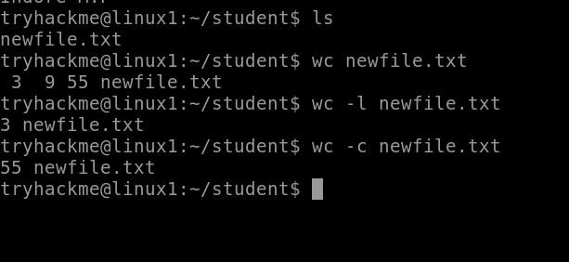

**33. du command:** The more command in Linux is a pager utility used to view the contents of files or command output one page at a time.

Syntax: more [OPTION] [FILE...]

Example:

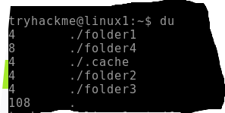

**34. less command:** The less command in Linux is a pager program used for viewing the contents of files or command output one screen at a time.

Syntax: less [OPTION] [FILE...]

Example:



**35. chown command:** The chown command in Linux is used to change the ownership of files and directories.

Syntax: chown [OPTION] USER[:GROUP] FILE...

Example:

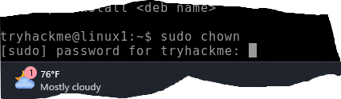

36. ipconfig command: The ipconfig command is used in Windows to display and manage the network configuration of your system. However, in Linux, the equivalent command is typically ifconfig or ip.

Syntax: ipconfig [OPTION]

Example:

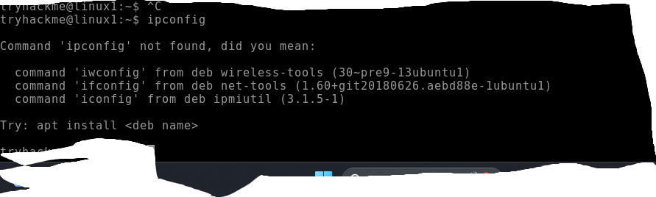

37. ifconfig command: The ifconfig command in Linux is used to configure and display network interface parameters for the operating system.

Syntax: ifconfig [INTERFACE] [OPTIONS]

Example:

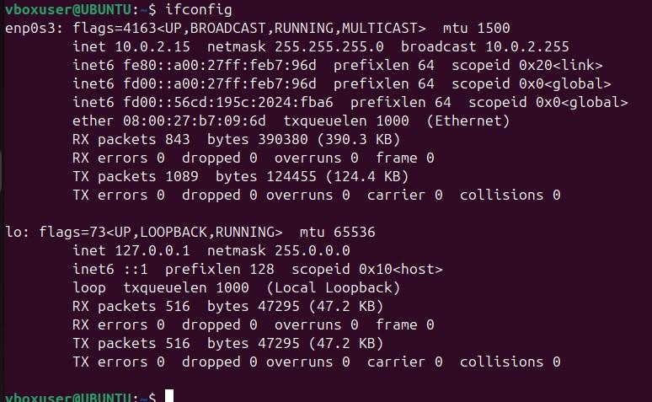

**38. ln command:**The ln command in Linux is used to create links between files. There are two types of links: hard links and symbolic (soft) links.

Syntax: ln [options] target [link_name]

Example:

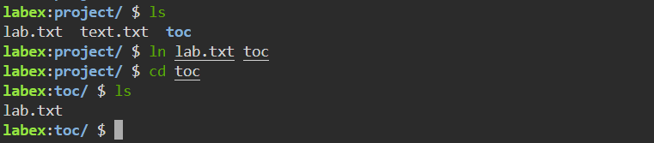

**39. rm command:** The rm command deletes files from a directory.

Syntax: rm [options) file1 file2

Example:

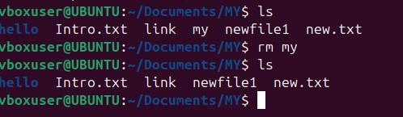

**40. whatis command:** The whatis command in Linux is used to display a brief description of a command or a system call. It provides a quick way to get an overview of what a command does, based on its man page.

Syntax: whatis [OPTION]... COMMAND...

Example:

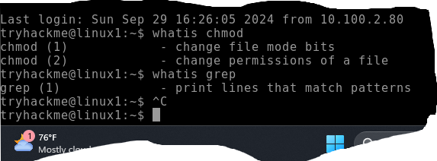

**41. pid command:** The pid command itself doesn't exist as a standalone command in Linux, but "PID" refers to the Process ID, which is a unique identifier assigned by the operating system to each running process. To work with PIDs, you typically use other commands like ps, top, kill, and pgrep.

Example:

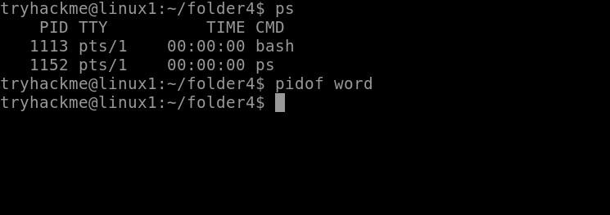

**42. chmod command:** The chmod command in Linux is used to change the file mode bits (permissions) of a file or directory. It controls who can read, write, or execute the file.

Syntax: chmod [OPTION]... MODE FILE...

Example:



**Linux Architecture**

Linux is an open-source UNIX-based operating system. The main component of the Linux operating system is Linux kernel. It is developed to provide low-cost or free operating system service to personal system users, which includes an X-window system, Emacs editor, IP/TCP GUI, etc.

**Components of Linux:**

Like any operating system, Linux consists of software, computer programs, documentation, and hardware.

**The main components of Linux operating system are:**

* Application
* Shell
* Kernel
* Hardware
* Utilities

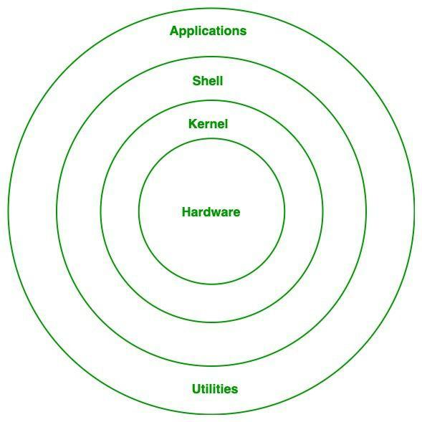

1. Linux Architecture

**Hardware Layer:**

Hardware layer of Linux is the lowest level of operating system track. It is plays a vital role in managing all the hardware components. It includes device drivers, kernel functions, memory management, CPU control, and I/O operations. This layer generalizes hard complexity, by providing an interface for software by assuring proper functionality of all the components.

**Kernel:**

[Kernel](https://www.geeksforgeeks.org/introduction-to-linux-operating-system/) is the main core component if Linux, it controls the activity of other hardware components. It visualizes the common hardware resources and provide each process with necessary virtual resources. It makes the process to wait in the ready queue and execute in consequently to avoid any kind of conflict.

**Different of types of kernels:**

**1.1. Monolithic Kernel:**

[Monolithic kernel](https://www.geeksforgeeks.org/kernel-in-operating-system/) is a type of operating system kernel, where all the concurrent processes are executed simultaneously in the kernel itself. All the processes share same memory recourses.

**1.2. Micro kernel:**

In [micro kernel](https://www.geeksforgeeks.org/kernel-in-operating-system/) user services and kernel services are executed in separate address spaces. User services are kept in user address space and kernel services are kept in kernel address space.

**1.3. Exokernel:**

[Exo-kernel](https://www.geeksforgeeks.org/kernel-in-operating-system/) is designed to manage hardware resources at application level. High level abstraction is used in this operating system to offer hardware resources access to kernel.

**1.4. Hybrid kernel:**

It is the combination of both monolithic kernel and microkernel. It has speed and design of monolithic kernel and modularity and stability of microkernel.

**Hypervisors**

A software package or kernel module extension that runs on a host OS and emulates hardware platforms for running guest OSes. VMware Workstation, Virtual Box, and QEMU are examples of hypervisors.

**Main Subsystems of kernel:**

* **Process scheduler:** Responsible for fairly distributing the the processing time among all the concurrently running process.
* **Memory management unit:** This kernel sub unit is responsible for proper distribution of memory resources among the concurrently running process.
* **Virtual file system:** This subsystem provides interface to access stored data across different file system and different physical media.

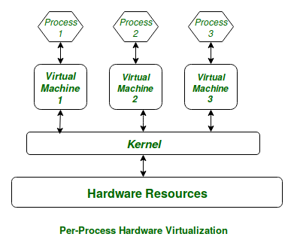

1. Linux Kernel

**Shell:**

[Shell](https://www.geeksforgeeks.org/introduction-linux-shell-shell-scripting/)can be determined as the interface to the kernel, which hides the internal execution of functions of kernel from the user. Users can just enter the commend and using the kernel’s function that specific task is performed accordingly.

**Different types of shell:**

**1. Command Line shell:**

Executes the command provided by user given in the form command. A special program called terminal in executed and the result is displayed in the terminal itself.

**2. Graphical User Interface:**

Executes the process provided by user in graphical way and output is displayed in the graphical window.

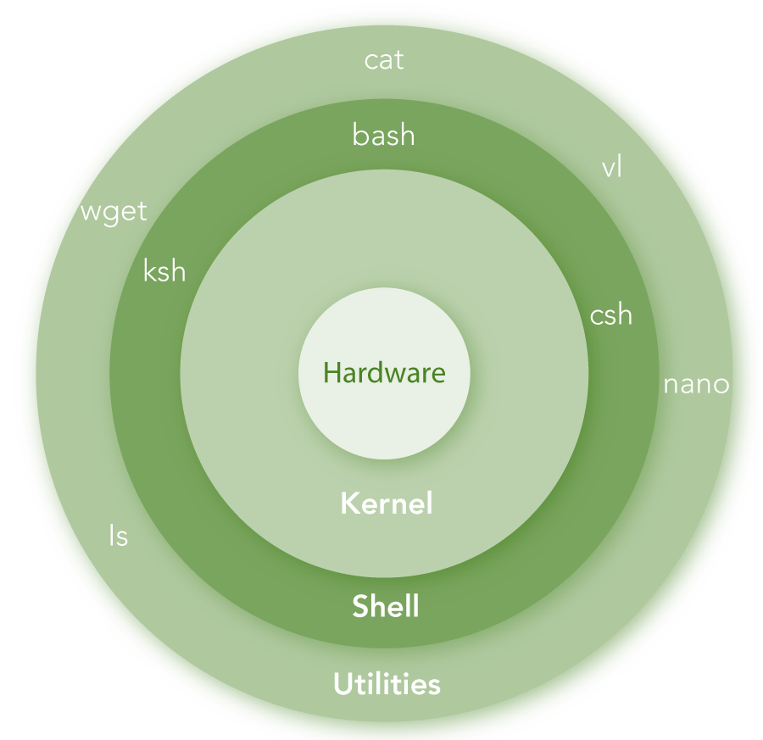

1. Linux shell

**System utility:**

System utilities are the commend line tools that preforms various tasks provided by user to make system management and administration better. These utilities enable user to perform different tasks, such as file management, system monitoring, network configuration, user management etc.

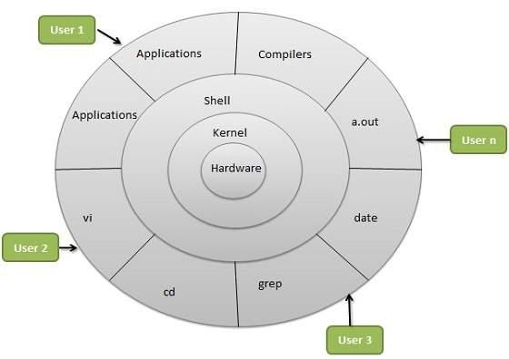

1. Linux OS Architecture

**Linux File System**

Operating systems, the software that powers your computer, rely on a crucial element known as the file system. Think of it as a virtual organizational tool that manages, stores, and retrieves your data efficiently. In the Linux world, a diverse range of file systems has emerged, each crafted to address specific needs and preferences.

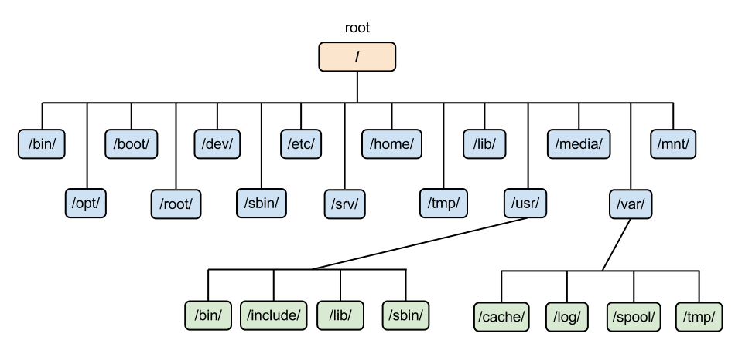

1. Linux File system hierarchy

The Linux file system is a multifaceted structure comprised of three essential layers. At its foundation, the Logical File System serves as the interface between user applications and the file system, managing operations like opening, reading, and closing files. Above this, the Virtual File System facilitates the concurrent operation of multiple physical file systems, providing a standardized interface for compatibility. Finally, the Physical File System is responsible for the tangible management and storage of physical memory blocks on the disk, ensuring efficient data allocation and retrieval. Together, these layers form a cohesive architecture, orchestrating the organized and efficient handling of data in the Linux operating system.

**Linux File System Structure**

A file system mainly consists of 3 layers. From top to bottom:

**1. Logical File System:**

The Logical File System acts as the interface between the user applications and the file system itself. It facilitates essential operations such as opening, reading, and closing files. Essentially, it serves as the user-friendly front-end, ensuring that applications can interact with the file system in a way that aligns with user expectations.

**2. Virtual File System:**

The Virtual File System (VFS) is a crucial layer that enables the concurrent operation of multiple instances of physical file systems. It provides a standardized interface, allowing different file systems to coexist and operate simultaneously. This layer abstracts the underlying complexities, ensuring compatibility and cohesion between various file system implementations.

**3. Physical File System:**

The Physical File System is responsible for the tangible management and storage of physical memory blocks on the disk. It handles the low-level details of storing and retrieving data, interacting directly with the hardware components. This layer ensures the efficient allocation and utilization of physical storage resources, contributing to the overall performance and reliability of the file system.

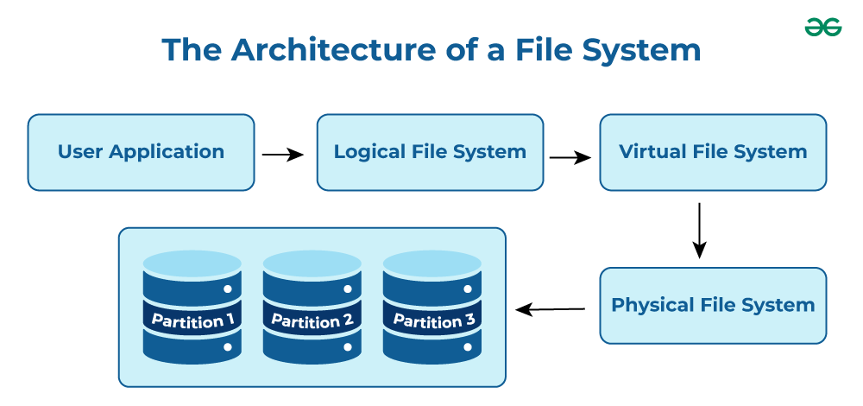

1. Architecture of Linux file system

**Characteristics of a File System**

* **Space Management**: how the data is stored on a storage device. Pertaining to the memory blocks and fragmentation practices applied in it.
* **Filename**: a file system may have certain restrictions to file names such as the name length, the use of special characters, and case sensitive-ness.
* **Directory**: the directories/folders may store files in a linear or hierarchical manner while maintaining an index table of all the files contained in that directory or subdirectory.
* **Metadata**: for each file stored, the file system stores various information about that file’s existence such as its data length, its access permissions, device type, modified date-time, and other attributes. This is called metadata.
* **Utilities**: file systems provide features for initializing, deleting, renaming, moving, copying, backup, recovery, and control access of files and folders.
* **Design**: due to their implementations, file systems have limitations on the amount of data they can store.

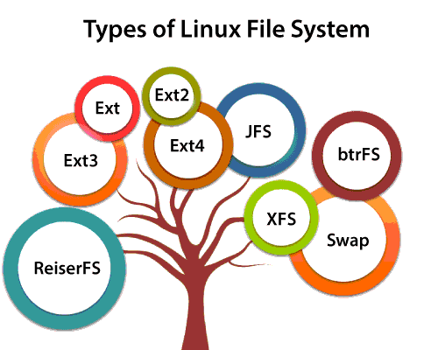

Following are some very short standard, defined, and well-known top-level Linux directory list and their purposes:

* **/ (root filesystem):** It is the top-level filesystem directory. It must include every file needed to boot the Linux system before another filesystem is mounted. Every other filesystem is mounted on a well-defined and standard mount point because of the root filesystem directories after the system is started.
* **/boot:** It includes the static kernel and bootloader configuration and executable files needed to start a Linux computer.
* **/bin:** This directory includes user executable files.
* **/dev:** It includes the device file for all hardware devices connected to the system. These aren't device drivers; instead, they are files that indicate all devices on the system and provide access to these devices.
* **/etc:** It includes the local system configuration files for the host system.
* **/lib:** It includes shared library files that are needed to start the system.
* **/home:** The home directory storage is available for user files. All users have a subdirectory inside /home.
* **/mnt:** It is a temporary mount point for basic filesystems that can be used at the time when the administrator is working or repairing a filesystem.
* **/media:** A place for mounting external removable media devices like USB thumb drives that might be linked to the host.
* **/opt:** It contains optional files like vendor supplied application programs that must be placed here.
* **/root:** It's the home directory for a root user. Keep in mind that it's not the '/' (root) file system.
* **/tmp:** It is a temporary directory used by the OS and several programs for storing temporary files. Also, users may temporarily store files here. Remember that files may be removed without prior notice at any time in this directory.
* **/sbin:** These are system binary files. They are executables utilized for system administration.
* **/usr:** They are read-only and shareable files, including executable libraries and binaries, man files, and several documentation types.
* **/var:** Here, variable data files are saved. It can contain things such as MySQL, log files, other database files, email inboxes, web server data files, and much more.